***Myntra-Clone***

# **The domain of the Project:**

# Full Stack Development

# **Team Mentors (and their designation):**

**Suhail Khan (Senior SoftWare Engineer)**

# **Team Members:**

Ms. Maneesha Katuri

# **Period of the project**

**October 2025 to December 2025**

Declaration

The detailed development project titled **“**Myntra Website Clone**”** was executed under the technical  
mentorship of Mr. Suhail Khan, Senior Software Engineer at ListenFirst Media, and facilitated by Sure Trust, spanning the duration from October 2025 to December 2025.

The primary motivation behind this undertaking was to rigorously simulate a corporate software  
 development environment. The core objective was to acquire advanced proficiency in Full Stack  
 Development by architecting a scalable, industry-standard e-commerce application, thereby  
 significantly elevating technical acumen and career readiness.

I formally declare that this project is a strictly educational, non-commercial interface replication  
 inspired by the Myntra E-commerce digital platform. It has been developed exclusively for academic  
 demonstration and skill validation. This system utilizes no proprietary backend infrastructure,  
 confidential datasets, or official APIs belonging to Myntra. All trademarks, logos, and brand assets  
 referenced herein remain the exclusive property of their respective copyright holders.

I confirm that the architecture, code implementation, and deployment strategies presented in this  
 project are the result of my independent work and research, reflecting a comprehensive mastery of  
 modern software engineering principles.

Team Members: Mentor’sName

Maneesha Katuri Mr. Suhail Khan

Senior SoftwareEngineer

ListenFirst Media

Prof. Radhakumari

Executive Director & Founder

Sure Trust

Table of contents

1. Executive summary
2. Introduction
3. Project Objectives
4. Methodology & Results
5. Social / Industry relevance of the project
6. Learning & Reflection
7. Future Scope & Conclusion

***Executive Summary***

This project aimed to develop a responsive frontend clone of the Myntra e-commerce website to strengthen practical skills in modern web development. The objective was to analyze the structure and design of a real-world online store, implement a modular React-based architecture, and ensure a seamless user experience across different devices.

The project was developed using React, HTML, CSS, and Redux for global state management. It includes all essential aspects of a complete React application such as reusable components, routing for smooth navigation, API integration for dynamic product data, Redux for managing global state (cart, wishlist, orders), and deployment. Modern development tools like Vite and Visual Studio Code were used during development.

The resulting application successfully replicates the core user interface and navigation patterns of the Myntra platform. This project provided a deeper understanding of scalable UI architecture, reusable component design, responsive layouts, and real-world application development. Future enhancements may include backend integration, real product data, authentication, and payment gateway features for a more comprehensive learning experience.

***Introduction***

With the rapid growth of online shopping platforms, providing a smooth, responsive, and visually appealing user experience has become a key requirement in modern web development. Myntra is one of India’s most popular fashion e-commerce platforms, known for its clean design, intuitive navigation, and rich product presentation. This project was developed as a frontend clone of the Myntra website to understand how real-world e-commerce applications are designed and implemented using React and related technologies.

The main goal of this project is to analyze the structure and functionality of a large-scale e-commerce platform and recreate its core features in a simplified yet effective way. The project focuses on building reusable React components, implementing seamless routing between pages, integrating product data through APIs, and managing shared application state using Redux. Through this approach, the project aims to strengthen practical knowledge of frontend development and industry-level best practices.

The scope of this project is limited to frontend implementation. It includes features such as product listing pages, filters, navigation menus, wishlist, cart, and basic order flow. Backend-related functionalities like real user authentication, payment gateways, order databases, and server-side logic are not included. Mock APIs are used to simulate product data and interactions, making the project suitable for learning and demonstration purposes.

An innovative aspect of this project is the use of a complete React-based architecture that closely resembles a real e-commerce application. The project applies modular component design, Redux-based global state management, clean URL routing, and responsive layouts to simulate a production-like environment. This approach helps in understanding how scalable and maintainable frontend systems are built and provides valuable hands-on experience in developing real-world web applications.

***Project Objectives***

## Objectives and Goals of the Project

* Develop a responsive frontend clone of the Myntra e-commerce website.
* Understand the design and workflow of a real-world fashion e-commerce platform.
* Build reusable and modular components using React.
* Implement smooth page navigation using React Router.
* Integrate product data using APIs and display it through product cards and grids.
* Apply filters such as brand, price, color, and discount similar to Myntra.
* Manage global state using Redux for cart, wishlist, and user interactions.
* Ensure the application works smoothly on all devices (desktop, tablet, mobile).
* Follow industry-level frontend development practices.

**Expected Outcomes and Deliverables**

* A fully functional frontend Myntra clone application.
* Well-structured and reusable React components.
* Responsive UI with consistent design across devices.
* Working product listing, filtering, wishlist, and cart features.
* API-integrated product data displayed dynamically.
* Redux-based global state management implementation.
* Deployed project accessible via a live URL.
* Clean, readable, and maintainable source code.

***Methodology and Results***

**Methods/Technology Used:**

The application is a modern Single Page Application (SPA) built using the React ecosystem.

* Frontend Framework: React (v19) with Vite as the build tool for fast development and optimized production builds.
* Language: JavaScript (ES6+).
* Styling: Tailwind CSS implementation for a highly responsive, pixel-perfect, and utility-first design system that mimics the original Myntra UI.
* State Management: Redux Toolkit is used for managing global application state, including authentication, cart, wishlist, products, and filters.
* Routing: React Router DOM (v7) handles client-side routing, enabling seamless navigation between pages without refreshing the browser.
* UI Components: Functional React components with hooks. External libraries include React Slick (for carousels), React Icons / Lucide React (for iconography).
* HTTP Client: Fetch API (native) is used to communicate with the backend services.

**Tools and Software Used:**

* **Core Logic:** JavaScript (ES6+), Semantic HTML5, CSS3
* **Frontend Framework:** React.js (v19)
* **Routing:** React Router DOM (v7)
* **State Management:** Redux Toolkit (Slices & Async Thunks)
* **Styling & UI:** Tailwind CSS, React Slick (Carousels), Lucide Icons
* **Build Tool:** Vite (Fast development & optimized bundling)
* **API Host:** MockAPI.io (RESTful API services)
* **Deployment & Hosting:** Netlify (Live hosting with GitHub integration)
* **IDE:** Visual Studio Code (VS Code)
* **Source Control:** Git & GitHub
* **Debugging Tools:** Chrome DevTools, Redux DevTools

### 

### 

### Data Collection Approach:

* The data used in this project is collected through mock REST APIs created using MockAPI.io. These APIs provide simulated product information such as product name, price, category, brand, images, and discounts. The data is fetched dynamically using the Fetch API and displayed within the application. No real user data or production databases are involved, and the data collection is strictly for educational and demonstration purposes.

**Project Architecture**

* The application is built using a modular and scalable frontend architecture with React and Redux Toolkit, optimized for high-performance data flow and component reusability.
* **App.jsx**

Acts as the central router and layout manager.

Handles conditional rendering of global Navbar and Footer across 20+ dynamic routes.

* **Pages/** (ListingPage, Bag, Wishlist, ProductDetails, etc.)

Contains 21 unique page components.

Each page represents a distinct view and a major segment of the Myntra user journey.

* **Components/** *(Navbar, Sidebar, Banner, Cards, Carousel)*

Implements a deeply nested component architecture.

UI elements are organized into sub-directories for maximum reusability and consistent styling.

**Navbar/** – Manages the complex mega-menu and search interface.

**Cards/** – Contains multiple card types *(*Category, Product, Grid) to handle different visual data patterns.

**Listing/** – Handles filter sidebar logic and product grid rendering.

* **Store/** *(*Redux Toolkit Ecosystem*)*

Serves as the central control room of the application.

Consists of **six Redux slices**: *auth, cart, wishlist, products, filter, orders*.

All slices are managed through a centralized **store.js**, ensuring a Single Source of Truth.

* **API Integration (productsApi.js)**

Acts as a clean abstraction layer for all external data communication.

Responsible for fetching real-time product catalog data from cloud-based APIs.

* **Unidirectional Data Flow**

Maintains a strict one-way data flow.

User actions (e.g., add to bag) dispatch Redux actions, which update the global state and re-render UI components without page refresh.

* **Utility Layer** *(slugs.js, productUtils.js)*

Contains helper functions for string manipulation, URL handling, and data formatting.

Helps reduce code duplication and improves maintainability.

* **Asset Management**

Uses centralized **assets/** and **public/** directories.

Manages high-quality images and static resources required for consistent visual presentation.

**Footer.jsx** is a global component in src/components/ that displays common website

information and secondary navigation across all pages.

**Final project working screenshots along with supporting explanation**

**Home Page**: The landing page that includes a responsive Navbar, Mega Menu, and dynamic sliding banners.

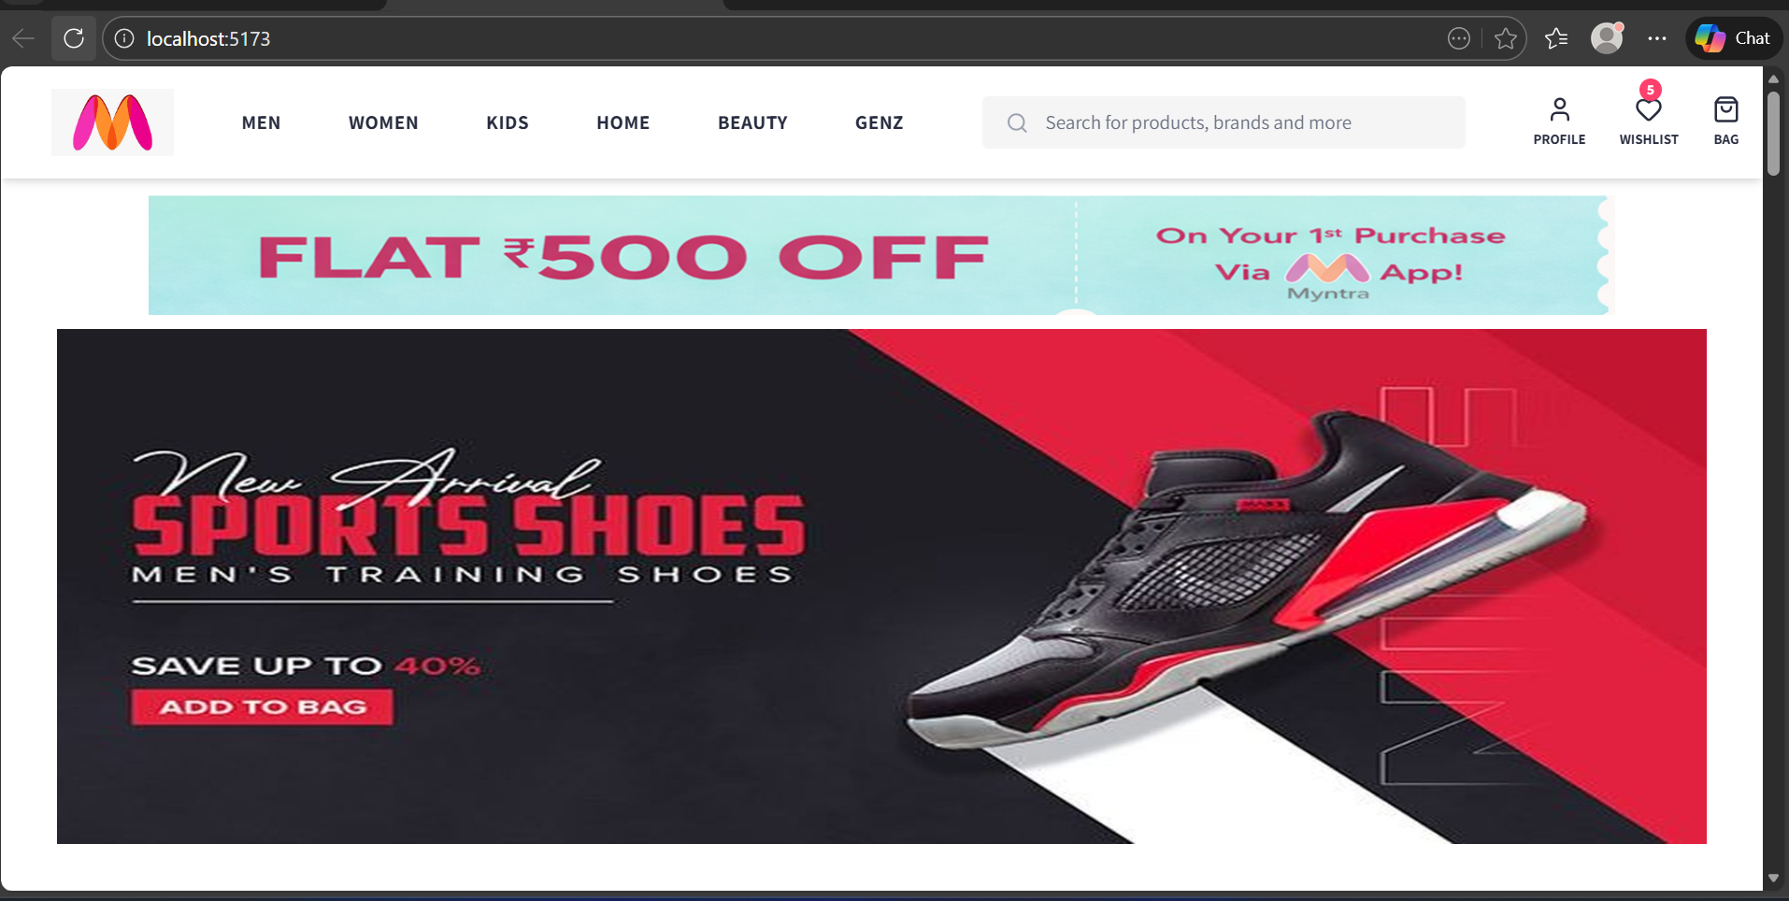

**Product Grid:** Displays multiple products with **Brand, Price, and Color filters** available in the sidebar.

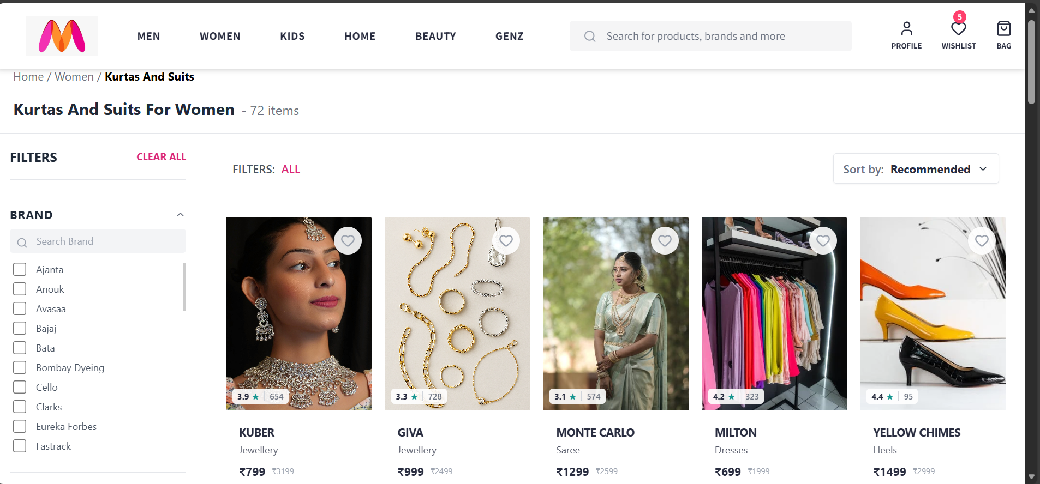 **Product Details:** A dedicated page displaying high-quality product images, size selection options, and an **Add to Bag** button.

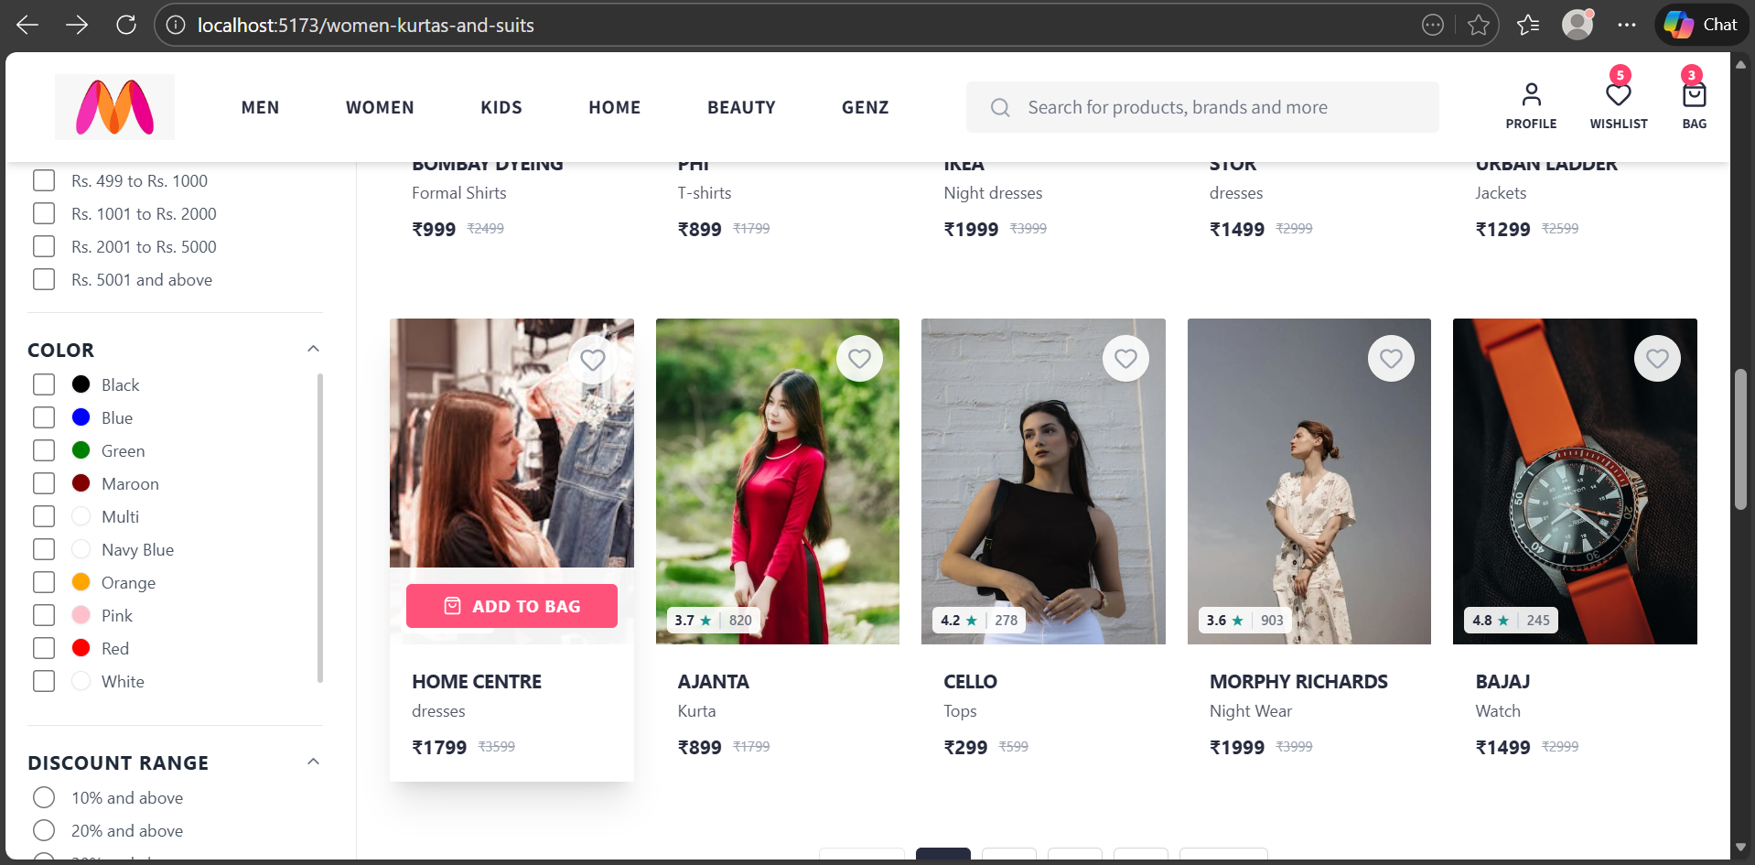

* **Shopping Bag:** The checkout area where users can manage selected items, view the total cost, and apply coupons before placing the order.

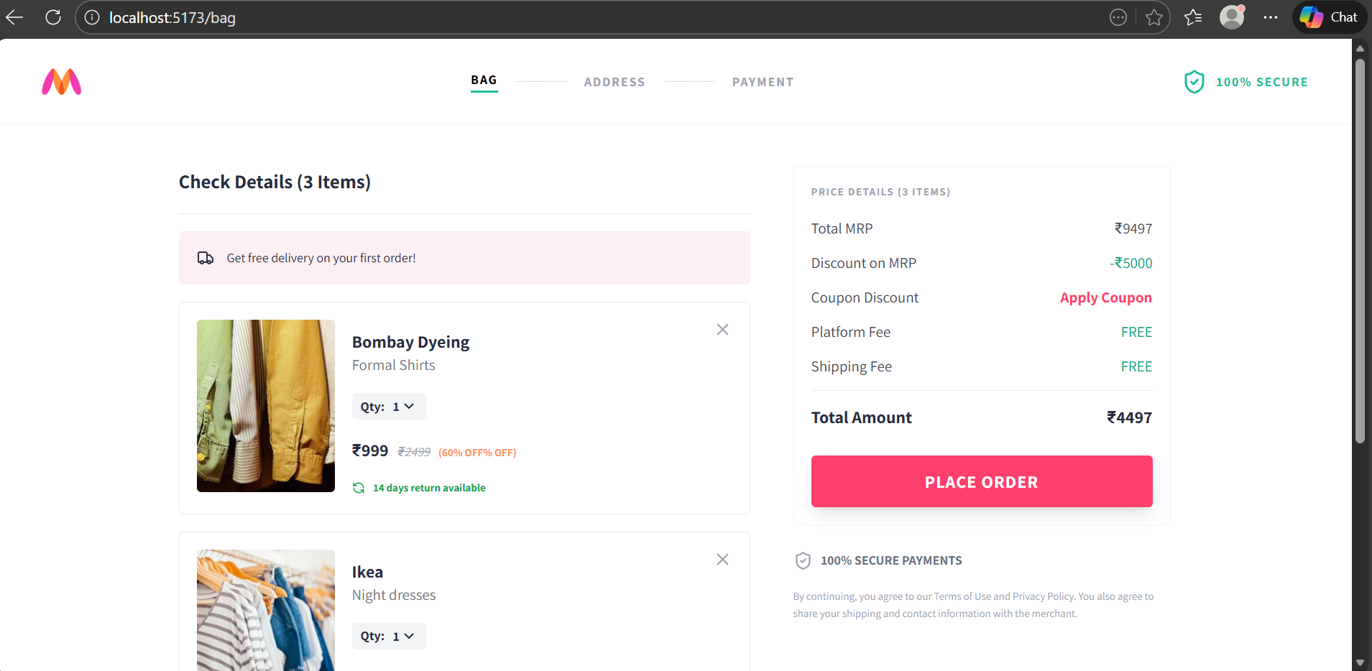

**Wishlist:** A section where users can save their favorite styles to view or purchase later.

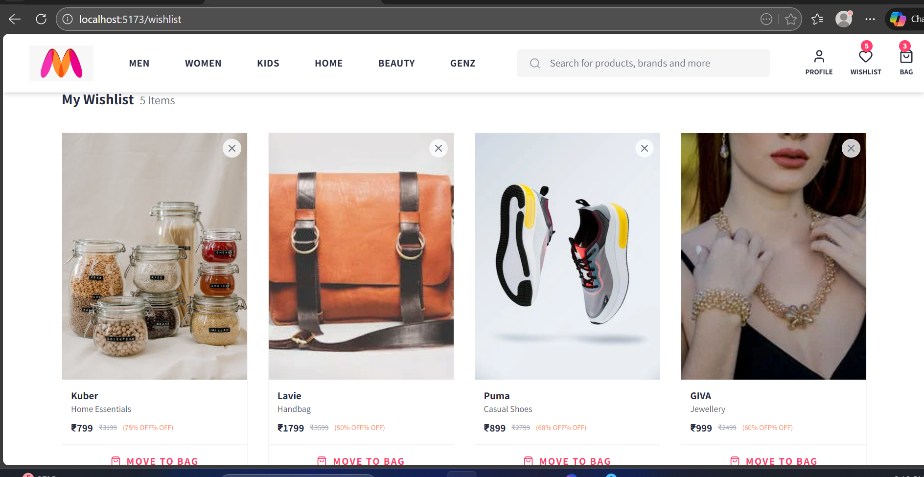

**User Profile:** A dashboard where users can manage their account details, saved addresses, and view recent orders.

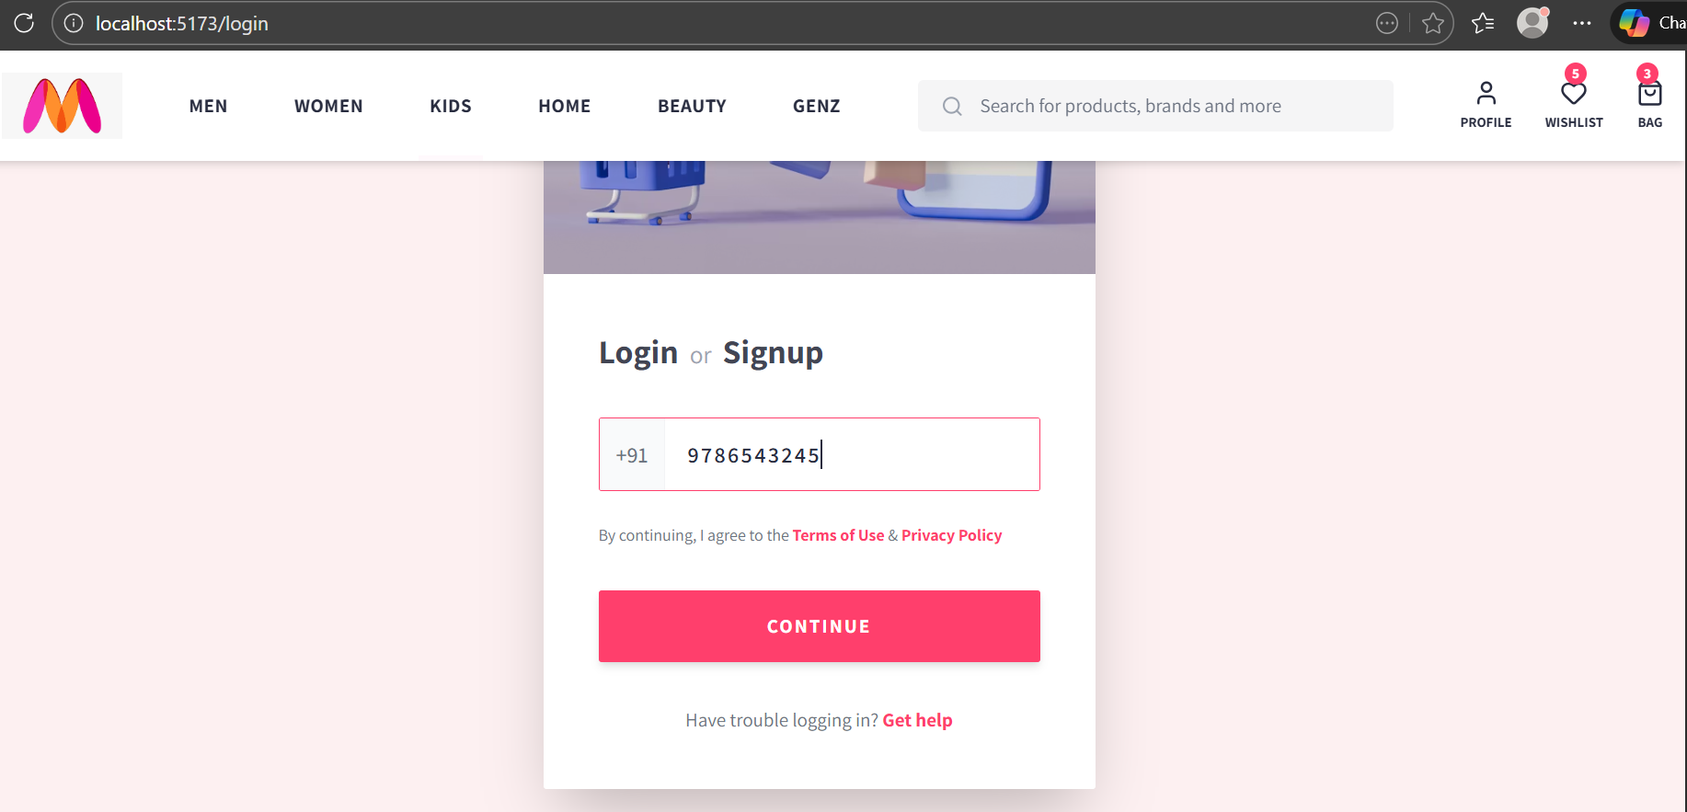

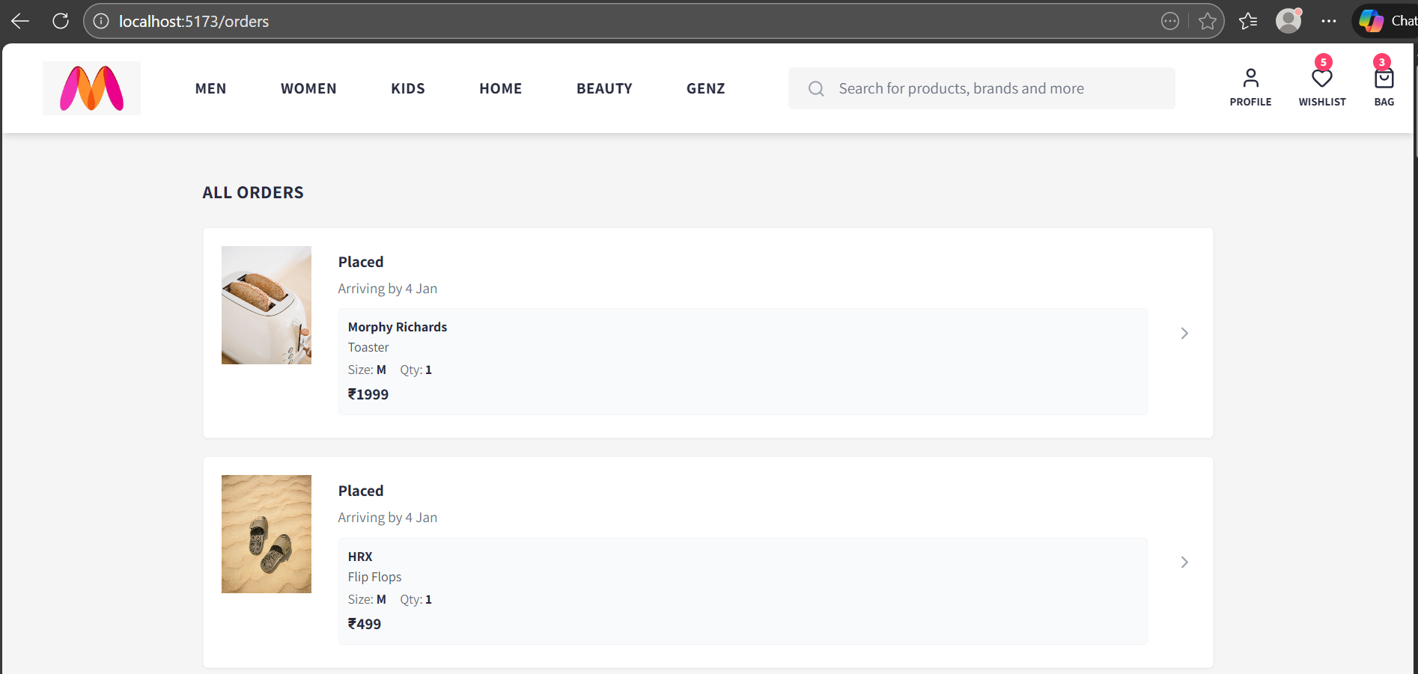

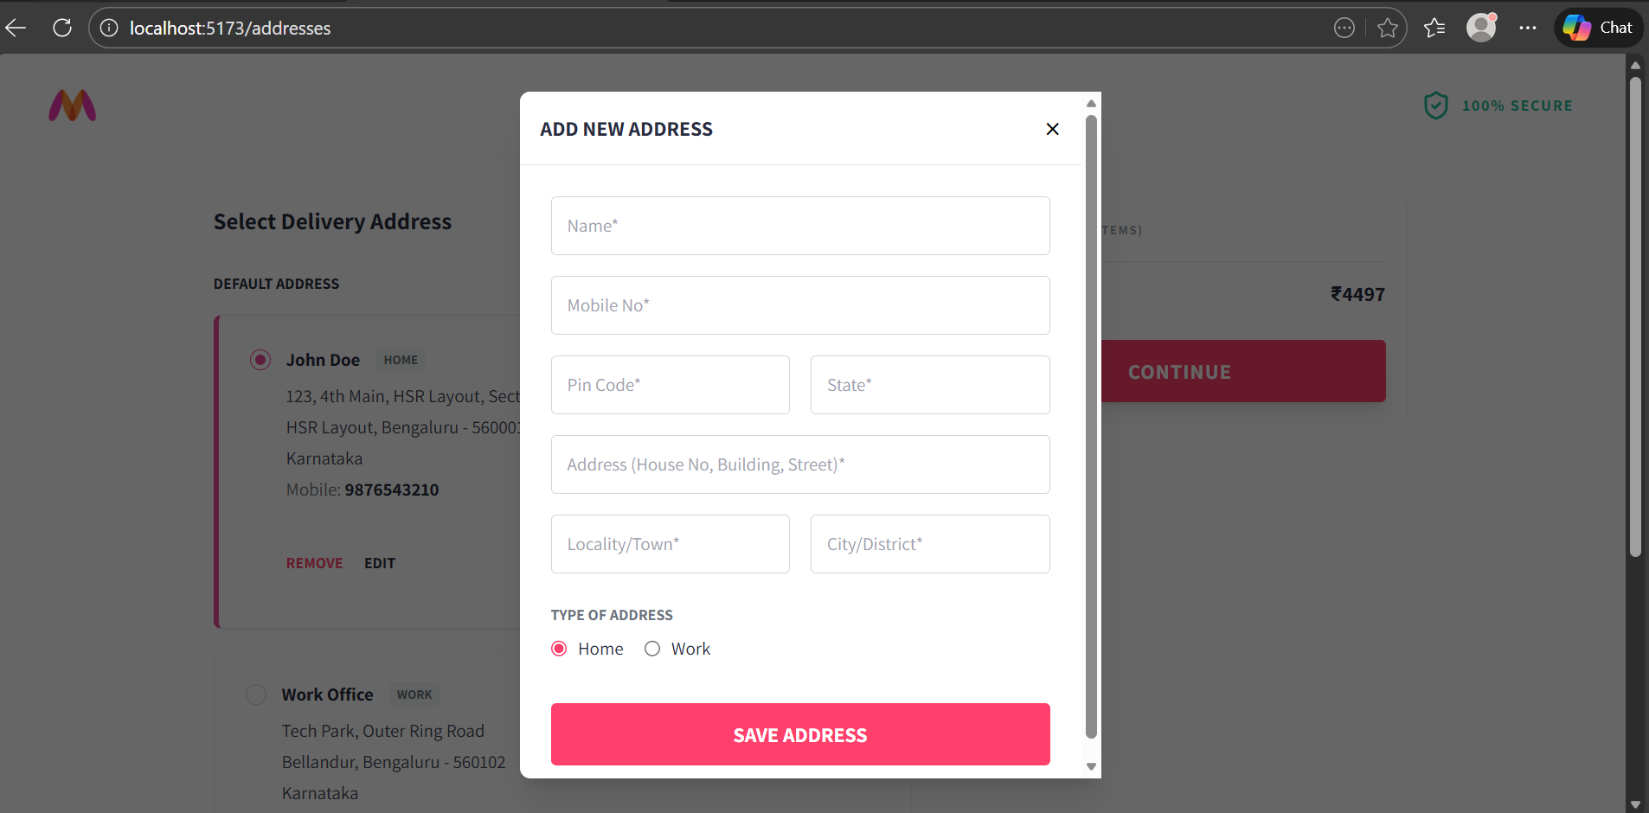

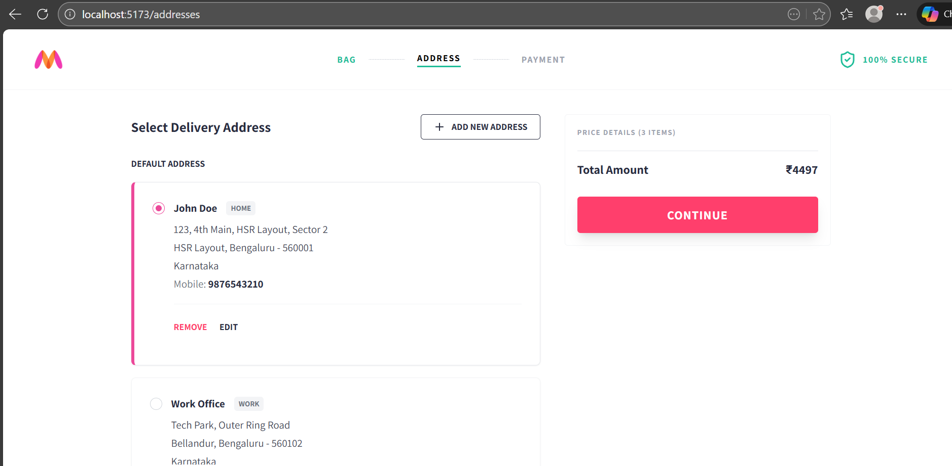

**Mobile View:** A responsive preview showing that the website layout automatically adapts for mobile and tablet devices.

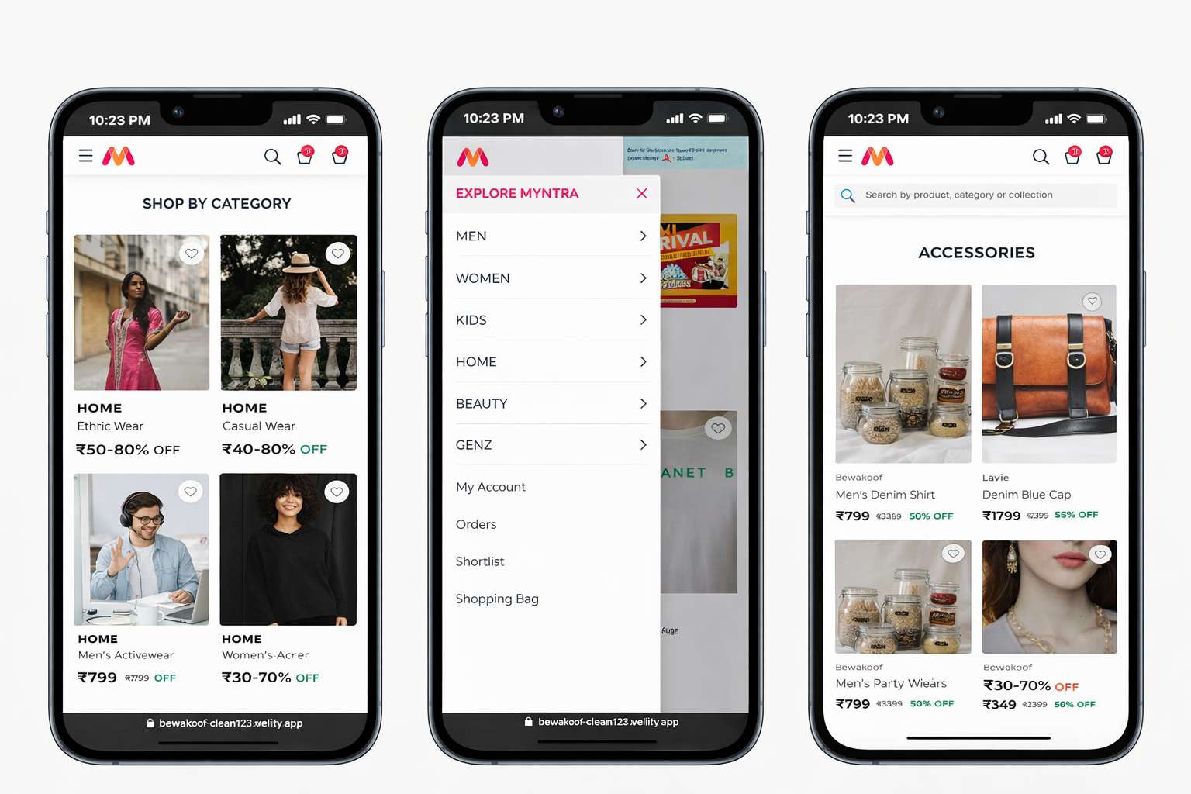

* **Footer:** A global section displayed across all pages that provides important site information, helpful links, and secondary navigation for users.

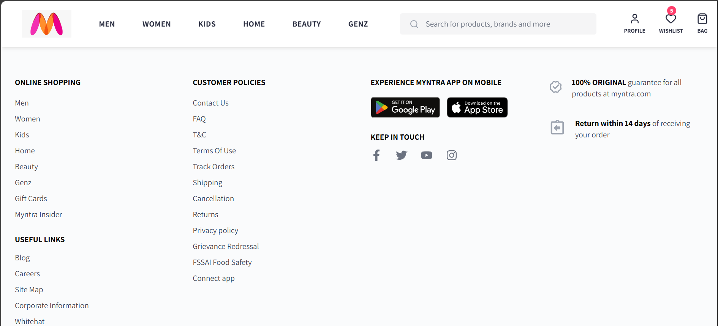

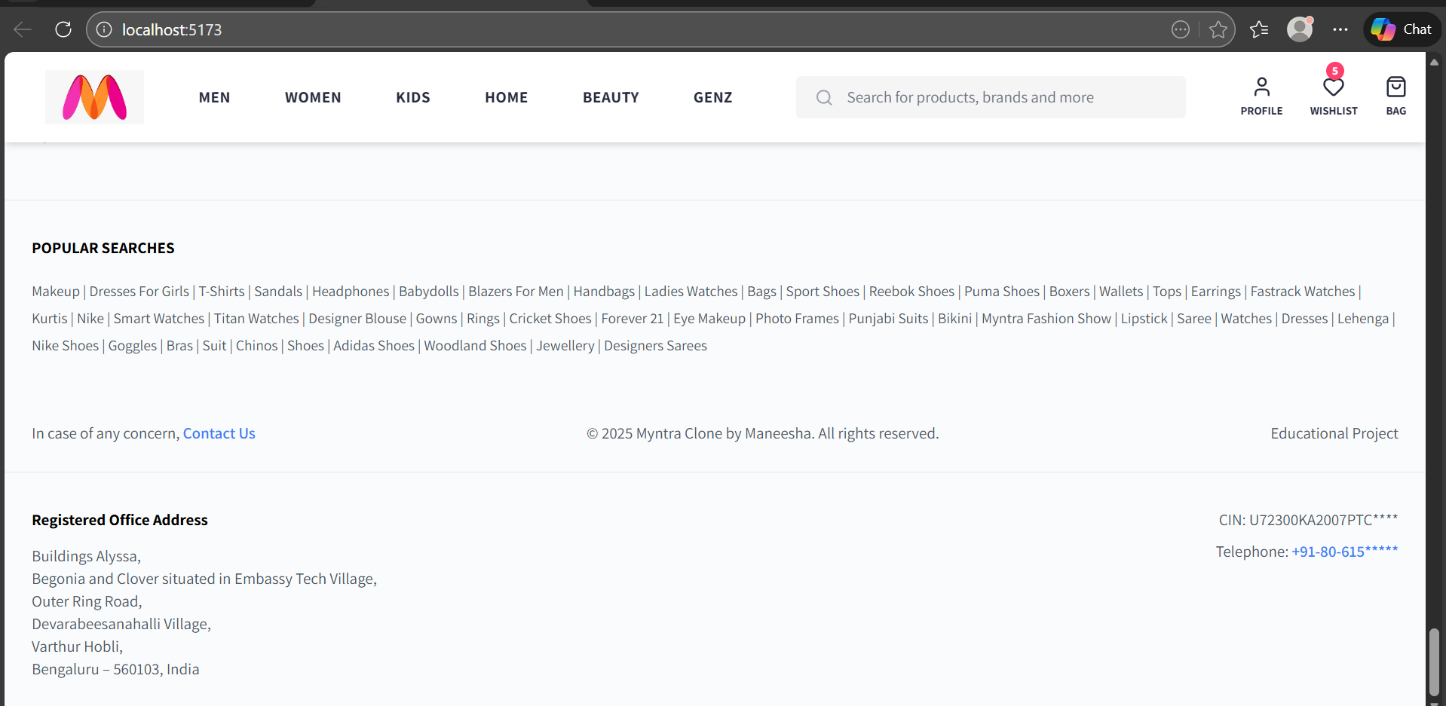

Project GitHub Link: https://github.com/Maneesha-7386/Myntra-clone

***Learning and Reflection***

### Learning and Reflection

**New Learnings**

**Technical Learnings:**

**Advanced State Management (Redux):** I learned how to use the Redux Toolkit as a "central brain" for the app. This allowed me to keep the shopping bag and wishlist updated perfectly across different pages without any data errors.

**API Data Handling:** I mastered how to connect my frontend to an external server (MockAPI). I learned how to fetch product data, handle loading screens, and display real-time information to the user.

**Modern Styling (Tailwind CSS):** I learned how to use Tailwind CSS to build a professional UI. This helped me match Myntra’s exact look (buttons, colors, margins) while making the website look great on mobile and desktop.

**Dynamic Routing:** I understood how to use React Router to create a smooth browsing experience. I learned how to move between categories and create specific pages for every single product automatically.

**Soft Skills & Management:**

**Full Ownership:** By building the entire Myntra Clone from scratch, I learned how to plan a project, manage the code files, and solve complex bugs independently.

**Priority Planning:** I learned how to focus on the most important features first (like the Shopping Bag and Navbar) before moving on to smaller design details.

**Problem-Solving:** My debugging skills improved significantly by using Chrome DevTools to find and fix errors in my logic and styling.

**Overall Experience**

Building the "Myntra Clone" as a solo developer was an incredibly rewarding journey that pushed my technical limits.

**Complete Understanding:** Creating this app helped me understand the full "big picture"—from how data is stored on a server to how it transitions through Redux and finally appears on the user's screen.

**Increased Confidence:** Successfully implementing difficult features, like the filters and the bag count logic, has given me the confidence to build any modern e-commerce application.

**Career Readiness:** This project simulated a real-world job environment. By managing the development lifecycle—from coding to GitHub and Netlify deployment—I feel fully prepared for a professional role in software engineering.

***Conclusion and Future Scope***

### Conclusion and Future Scope

* **Recap objectives and achievements**

The primary goal of this project was to architect and develop a fully functional, high-fidelity clone of the Myntra e-commerce platform.

By simulating a real-world development lifecycle, I successfully turned theoretical knowledge into a professional-grade application.

* **Key Achievements:**

**Exact UI Replication:** Successfully recreated Myntra’s complex visual identity, including the Mega Menu, Product Grids, and responsive layouts that work seamlessly across desktop and mobile devices.

**Centralized State Management:** Engineered a robust global state system using Redux Toolkit to handle dynamic data for the Shopping Bag, Wishlist, and User Authentication.

**Dynamic API Integration:** Built a functional data layer that fetches real-time product information from external REST APIs, enabling features like live filtering and sorting.

**Modern Build Pipeline:** Delivered a high-performance Single Page Application (SPA) using Vite and React Router, ensuring fast load times and instant page transitions.

* **Future scope of this project**

While the current version serves as a comprehensive educational milestone, there is significant potential for evolving it into a production-ready commercial platform.

* **Planned Enhancements:**

**Backend Migration:** Transitioning from a mock API to a scalable backend using Node.js and MongoDB to handle secure user databases and real product management.

**Payment Gateway Integration:** Implementing secure third-party processors like Stripe or Razorpay to enable real monetary transactions and secure checkout flows.

**Admin Dashboard:** Developing a dedicated portal for merchants to manage inventory, update product details, and track real-time sales analytics.

**AI Recommendations:** Integrating machine learning algorithms to suggest personalized products to users based on their browsing history and preferences.

**SEO Optimization:** Refactoring the application to Next.js for Server-Side Rendering (SSR) to improve search engine rankings and initial page load speeds.